CURRENT STATE AND RESIDUAL LIFE EVALUATION OF FORMING ROLLS BY MAGNETIC (ON COERCIVE FORCE)
NDT TECHNIQUE

V.F. Muzhitskiy, JSC “RII MSIA "Spectrum", L.A. Krutikova, “Novolipetsk Iron & Steel Co”,
I.L. Kazyukevich, JSC “SeverStal”, Russia, B.E. Popov, UCK “Kran”, Russia,
G. Ya. Bezlyudko, SIC “SNR”, Ukraine.

Abstract

This paper presents the application of magnetic (on coercive force – H_{c}) technique for the evaluation of the current state and residual life of mill rolls in hot rolling and cold rolling steel mills. Sixty rolls have been examined. It is shown that the increase of the H_{c} value is about twofold for the period from putting the roll into operation up to the moment of complete deterioration of its working layer. The investigation results of the distribution of H_{c} irregularity degree on the surface of roll in operation are presented. The results enable optimization of the roll rout for the mill stands to avoid stress concentration on the same depth of the working layer of roll after every campaign. Application of this magnetic technique let evaluate effectively the current state of the working layer of mill rolls with fatigue phenomena.

An actual metal market gives rise for searching the new solutions for reduction of production costs. The solutions improving the most expended elements of the market are most attractive. The proposals which could be implemented with minimal cost and time are most interesting and valuable. This kind of problems was solved by the example of metallurgical work “SeverStal”, Cherepovets, Russia.

In scale production of hot- and cold-rolled sheets capital and operation costs are the essential parts of cost value of finished products. The approach under consideration improves the use efficiency of the rolls available. Thereby, the approach reduces the operation cost with simultaneous quality improvement of the rolled metal due to more accurate following and accounting the current state of each roll for the whole service life starting from acceptance test up to controlled expiry.

The approach is based on the non-destructive technique of monitoring (for the whole service life) deflected mode of each roll on the whole and especially the state of the working layer on measurement of such a characteristic as a coercive force – H_{c}. The similar approach has already been admitted for a log time in metallurgy and machinery for the delivery trial of finished metal production on mechanical properties. For this purpose GOST 30415-96 “Steel. Non-destructive testing control of mechanical properties and microstructure of steel products by magnetic method” was passed in Russia. When searched the direction of this work, besides these initial aspects two more were taken into consideration, namely, the coercive force is most structure-sensitive characteristic of the metal magnetic characteristics, and fatigue changes in metal are mainly metal micro- and macrostructure changes. The H_{c} structure-sensitivity could be compared only with metallographic analysis and structure X-raying. They are, however, laboratory techniques and are not suitable for manufacturing environment. It was decided to test mechanical properties on the H_{c} measurement not only a new metal (a new roll), but follow the dynamic of metal change in the working layer for the whole service life of a roll. Special attention was paid to find not only the main dependence between the H_{c} value and a period of service life of roll, but a possibility to reveal the local phenomena in the H_{c} value distribution on the roll surface. The phenomena are the reasons of residual stress accumulation in the work layer that leads to delamination and spalling.

It is shown below that the Hc measurement of the roll surface during its service life the parameter under consideration justified the expectations. In a practical situation Hc is measured in a manual or an automatic way. The evaluative criteria are strictly determined and uniquely dependent. Then, the increase of the value of coercive force of the roll service is about twofold. Such measurement of the informative parameter at simple and cheap inspection allows coercimeterics to effectively solve the problems of effectiveness increase of the rolls operation from a moment of their putting into operation and be beyond comparison of the other available techniques for solving similar problems nowadays.

All this group of sixty rolls has been inspected for a year and a half. Before examining the working surface was grinded. The coordinate grid was snapped to the roll construction to measure the parameter in the same points when roll changed. The measurements were performed by the magnetic structure analyzer KRM-C-K2M. The surface of each roll was examined in two hundred points.

The distribution of the H_{c} value was analyzed depending upon the volume of the production rolled during the whole service life of each roll (see fig. 1). It is evident that the change of average of distribution and variance of the H_{c} values is more than twofold. Along with the traditional techniques for the surface hardness measurement were employed for this kind of measurements (see fig. 2). They are not so informative because the hardness change is about several percent. By the analysis of the measurements on the whole sample of rolls the empirical dependences were obtained. They determine residual life of each roll by its ‘personal’ H_{c} value distribution at any moment, i.e. its current state.

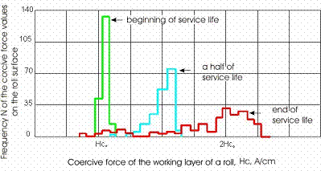
Fig. 1. Dependence between the coercive force distribution on the steel roll surface and the volume of production rolled (service period).

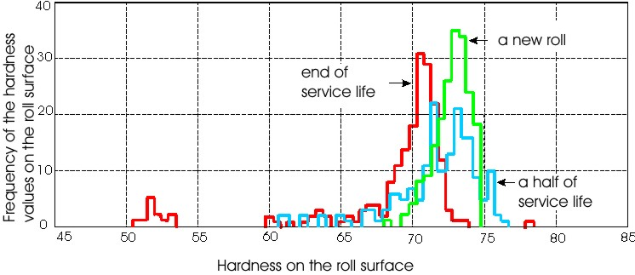
Fig. 2. Dependence between the hardness distribution on the steel roll surface and the volume of production rolled (service period).

The examples of bivariate distribution on the roll surface are shown on figures 5, 6, 7 and 8 and they are of a particular interest. The degree of irregularity in the coercive force distribution of one of the rolls (roll №72) is essentially greater. Keeping this roll under observation let us follow the birth process, formation and development of the stress concentration area for several roll campaigns up to a breakdown with the surface layer damaged. The techniques of hardness measurement and ultrasonic flaw detection were unable to follow this process.

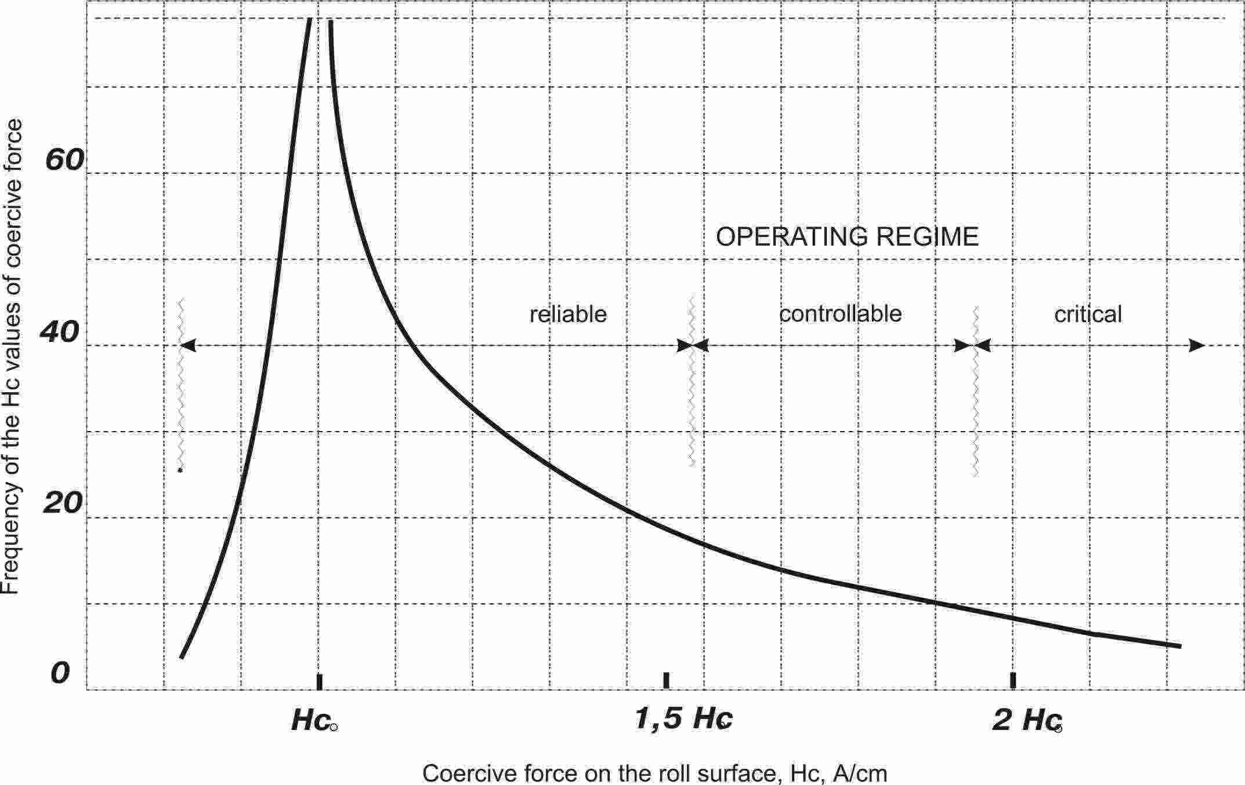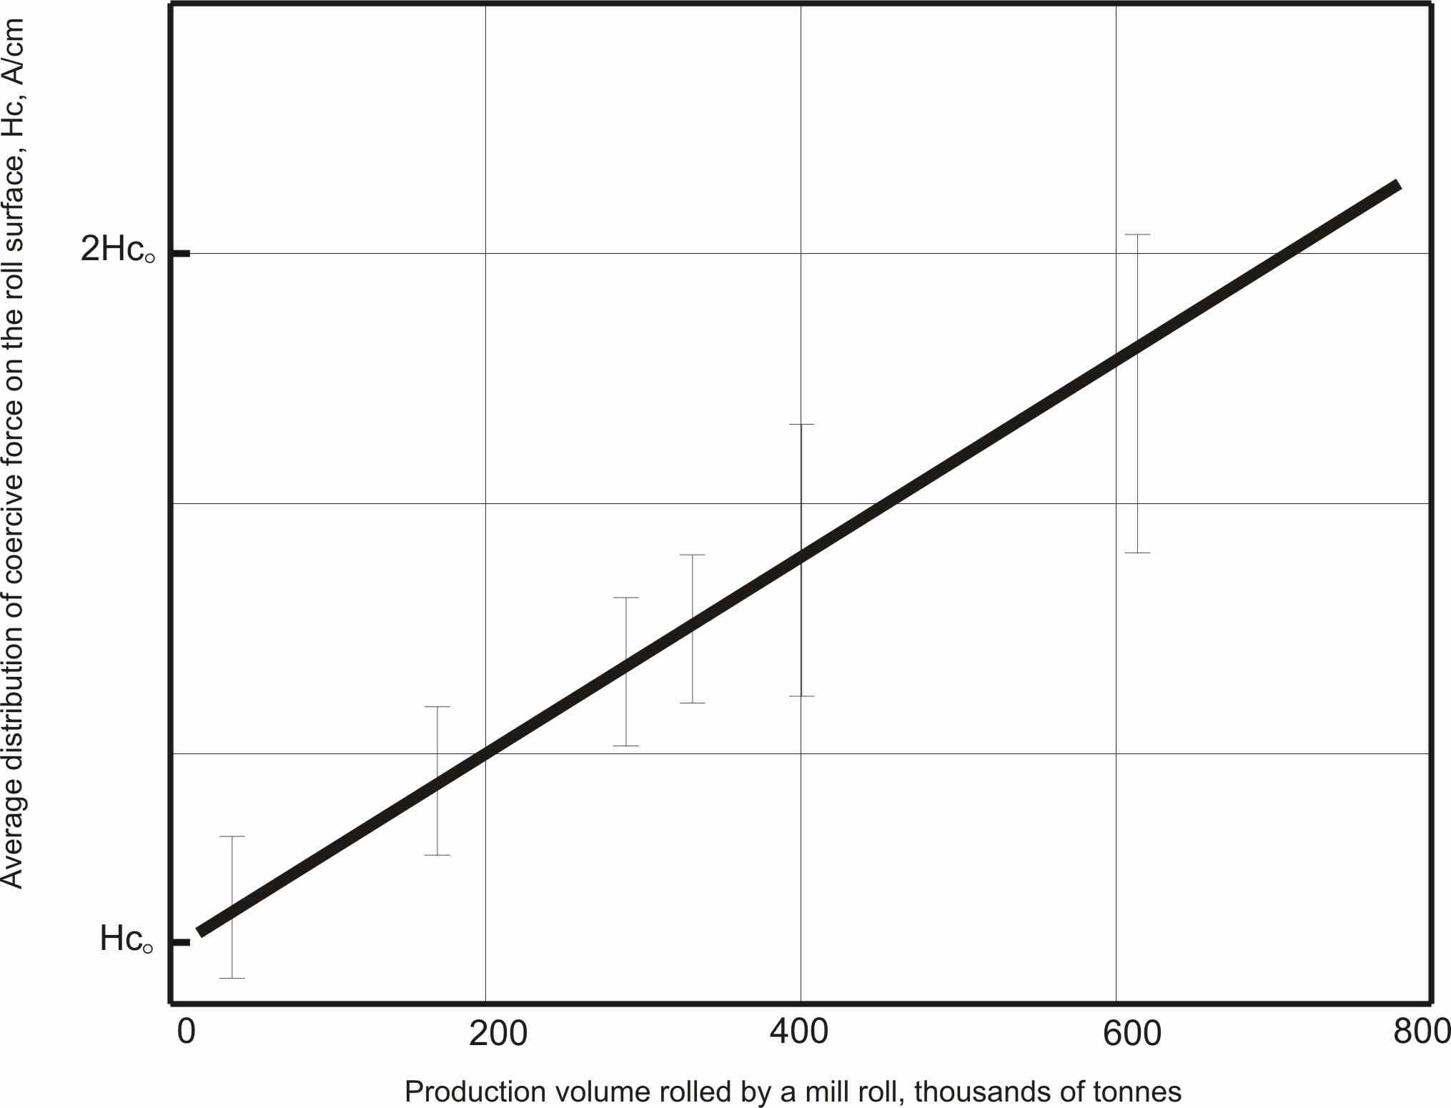
Fig. 3. Global distribution of the coercive force values on the roll surface (H_{c0} – average of distribution on the surface of a new roll)
Fig. 4. Dependence between average
of distribution of the coercive force and the production rolled

Along with the evident efficiency of the Hc measurement as a parameter at the current inspection of roll we should also note that the research data could completely be supplemented with another characteristic – the Hc distribution on depth of the working layer. It will allow us to inspect reliably the depth of occurrence of maximal stress concentration layer. The possession of such a kind of reliable information for every roll change let optimize the roll rout on the mill stands to avoid stress concentration on the same depth of the working layer when roll changed and, thereby, avoid its premature failure. Moreover, the process could be easily automatized via the stationary devices on the roll grinding station.

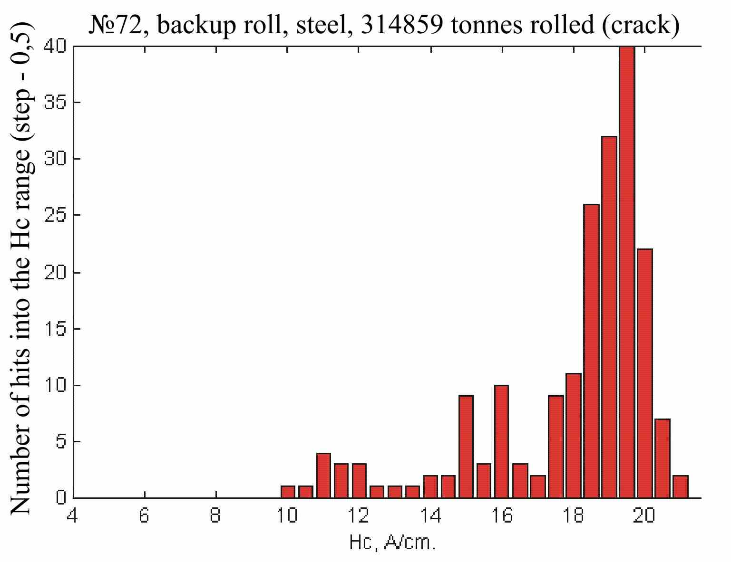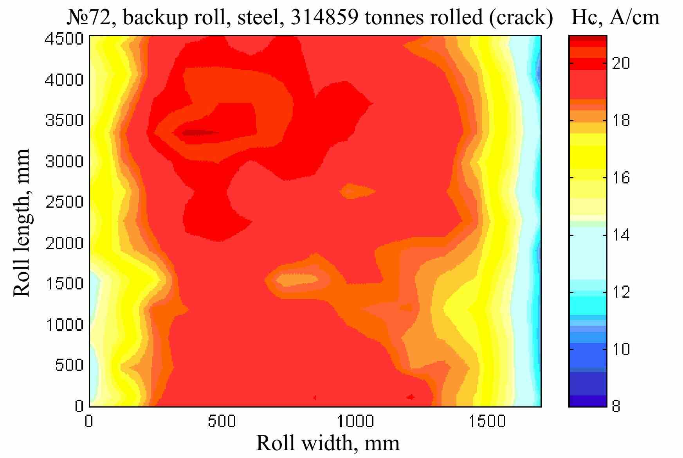

Fig. 5. Example of the Hc distribution
on the surface of roll №72
Fig. 6. Example of the bivariate distribution
of the Hc values on the surface of roll №72

It gives a unique possibility to reduce labour intensity of coercimeteric inspection, increase its reliability, and make data storing for every roll simple for the service life beginning from the incoming inspection. It will also let follow continuously the operation quality rolls on state after every roll change and basing on this to soundly establish the correct terms of maintenance with no rely on average statistical norms, and set the specific parameters as well for the roll maintenance being guided by its actual state. Preliminary analysis brings out clearly the essential gain when moved from the statistical criteria to their selection ‘on state’ individually for every roll. Most encouraging possibilities are an accurate localization and a degree of breakdown of anomalous sites of the working layer and clear data check of recovery and preventive actions to the sites. There is, besides maximal prolongation of the roll service life, a possibility to prevent the wrecking stoppage of a rolling mill when damaging the rolls in operation process.

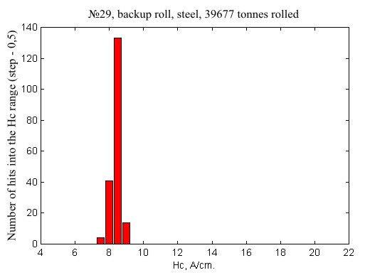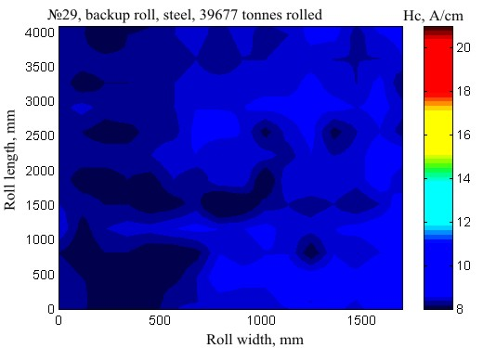
Fig. 7. Example of the Hc values distribution on the surface of roll №29
Fig. 8. Example of the Hc bivariate distribution on the surface of roll №29

It is evident from the above that this work adds an effective and simple instrument for the current inspection of accumulation degree of fatigue effects to the familiar classical concepts of fatigue development process. It allows us to move from average statistical to controllable and even optimization criteria of operation of the rolls ‘on state’ for all stages of their service life and, thereby, cut down production price with inevitable quality improvement owing to the increase in operation quality of rolling-mill machinery. The introduction of such a coercitimetric monitoring, by the conservative estimations, will allow us to reduce the operating factor cost of rolls by 10% with a pay-back period estimated to be not more than a half of a year.

The coercitimetric technique is equally efficient for the inspection of both cast-iron and steel new rolls at manufacturing plants. And at that especially significant results were obtained under joint analysis of the data of outgoing coercitimetric inspection of a new roll with the data of service life of the same roll and its operation features at a rolling-mill. The method of iron rolls inspection differs from the inspection of steel rolls little. It is also informative and effective in case of the correct account of iron properties (for all kinds of iron) as a material for roll production and iron behaviour features on all the stages of service life as well.

References:
- Kroutikova L., Shashenkova J. About CIS Standard GOST 30415-96. Pros. 7-th Erop. Confer. on NDT. Copenhagen. 26-29 May 1998. p. 350.
- Kroutikova L., Muzhitsky V., Popov B., Bezljudko G. Magnetic Inspection of Stressed State Condition and Residual Resource of Steel Works. Pros. 7-th Erop. Confer. on NDT. Copenhagen. 26-29 May 1998. p. 351.
- Kroutikova L. GOST standard 30415 Non-Destructive Testing Control of Mechanical Properties and Microstructure of Steel by Magnetic Method. Doc. № v-1168-00. IIW. July 12. 2000.
- Bezljudko G., Kroutikova L., Prokopenko P. History and Perspectives of the CIS Standard GOST 30415-96 “Steel. NDT Control of Mechanical Properties and Microstructure of Steel Product by Magnetic Method Doc. N: v-1168-00. IIW. July 12. 2000.
- Muzhitsky V., Popov B., Bezljudko G. Magnetic Method and Instrumentation for Inspection of Ferromagnetic Steels. Shattering Process for the Metallic Structures. Residual Resource Evaluation of Machines and Vessels Working under Pressure. Pros. 15-th World Confer. on NDT. Rome. 15, 21 Oct. 2000.

