NEW APPROACHES ON NDT OF THE CURRENT STATE AND
RESIDUAL LIFE OF PRESSURED VESSELS

V.F. Muzhitskiy, JSC “RII MSIA "Spectrum", B.E. Popov, UCK “Kran”, Russia;
V.M. Dolinskiy,UkrNIIHimmash, G. Ya. Bezljudko, SIC “SNR”, Ukraine

The real current state of metal at the diagnostics of objects without fundamental attitude for normative service life is acknowledged everywhere because it realizes most effective combination of principles of economy and safety during the use of objects. For the approach, however, to be rather virtual and efficient than declarative instrument for the diagnostics, suitable for mass application it is necessary to solve a number of problems, e.g. the search of a universal, easy controllable and most informative parameter for testing the ‘state’. Then, it is essential to develop the method, equipment base, elaborate the standard base and after that teach minimum of specialists to inspect the state by the new technique. The number of specialists should be sufficient for their independent existence and development.
Since the diagnostics appeared the absence of practical techniques on the evaluation of development and accumulation of the fatigue effects in metalworks led to identification of two notions “diagnostics” and “defectoscopy” even between the specialists. It happened through the permanent development of the NDT techniques assuming more and more diagnostics problems. Sometimes the problems were not peculiar to the defectoscopy due to the absence of real practical techniques to inspection of free of flaws metal. However, the fact that for the late decades the breakdown rate of objects has not decreased is not controversial. It happens in spite of the increase in inspecting work content and investments in this field for both the new metal products and the objects in operation. It gives ground to suppose that it is likely the possibilities of inspection techniques are exhausting. The complex diagnostic estimation is mainly formed in practice on conceptions and views of defectoscopy. This peculiar narrowness apparently arose impartially and historically. The narrowness was difficult to be changed until the objective prerequisites were created, namely, perception of vainness of the defectoscopy techniques of free of flaws metal, but with developed and accumulated fatigue that highly influences on the service life prediction. Moreover, in a number of cases the diagnostics can not be fundamentally based on the information obtained by defectoscopy. It is a case when the defects appear and result in an immediate breakdown of object. In that case the defect is not managed to be revealed. And in general the flaw detection by any techniques for the objects in operation is labor intensive and expensive work with low productivity and reliability. In addition, the operational defects arise and develop as rule at the completion stage of metal life. And the fatigue changes before that stage develop and accumulate slowly and gradually during the most intensive period of operation. These processes are developing very intensively in the zones of the fatigue concentrations. The zones are quite vast and their location is well known at the stage of object designing. That is why the fatigues are easy to be discovered and evaluated if there is an effective monitoring parameter. Moreover under such approach the moment of the defect appearing can be warned that is significant from the point of strategic principles and aspects of diagnostics. The breakdowns happen, but it is easier and chipper to prevent them than to clear.
All the above initiated the search of the techniques to solve the problems arose. The solution was found while analyzing the possibilities of well known in metallurgy and machinery an ND technique as a technique of testing the mechanical properties and microstructure on the magnetic characteristics (under the Standard GOST 30415-96). The technique was in common practice but for the delivery trials of the new metal production. It took 5 years to find more acceptable parameter of all magnetic characteristics – coercive force Hc. The parameter is suitable for the service inspection to estimate and evaluate the fatigue changes including the life expectancy. All this should also meet the requirements of mass usage by the specialists to whom the technique is quite new. The test and additional work on principle grounds of the technique and instruments lasted for the same period.
Here some new aspects of the new tendency are considered. Figure 1 shows the generalized limited characteristic of loading a tensile sample or a complete product (points H_{c0}, A₀, A₁, A₂, A₃, and A₄). In our case it is a high pressured gas vessel (under standard GOST 949). The particular definition of the object has no influence on the discussion. The object was loaded via the test desk, starting from the beginning of operation – H_{c0} up to a death point – A₄. It is evident that the object can be damaged by a single continuous increasing load or multiple load cycles with specified or increasing amplitude (low-cycle fatigue). Figure 1 conditionally shows three increasing cycles. The coercive force of the object under test is a reliable parameter of overloading the vessel coat over the yield point and a stage of depletion of the original service life R₀ at static and cyclic loads. Thus, the search problem of an effective parameter for inspecting fatigue processes is found as far as while metal changing from its original state up to a moment of predestruction (H_{c0}→H_{c}^{B}) the increase of the Hc value may range between 2 and 3 (depends on steel grade). The problem was realized in practice when JSC “RII MSIA “Spectrum”, Russia and SIC “SNR”, Ukraine managed to design and manufacture the portable magnetic structure analyzer KRM-C-K2M that allowed the average operators to simply and reliably measure the value of coercive force.
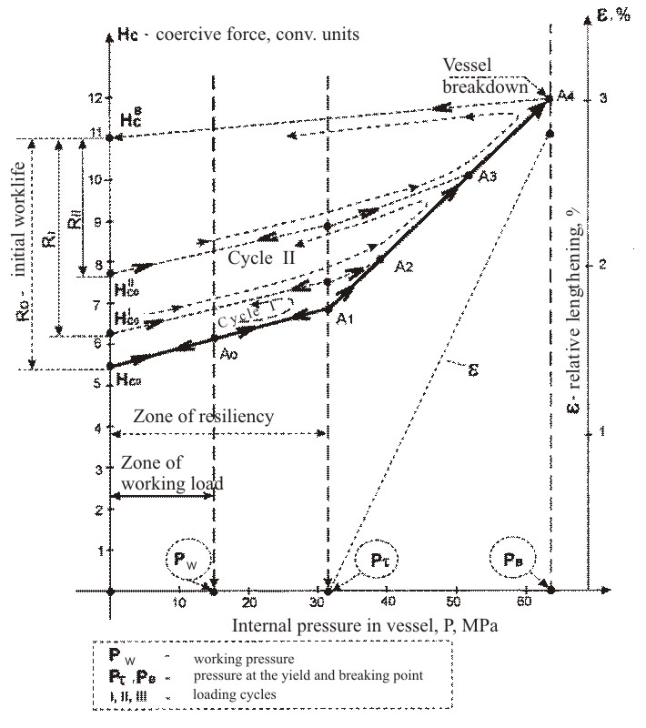

Figure 1. Magnetic control of the gas vessel under the loading and unloading

The main conclusions from figure 1. On the basis of the coercimeterics it is possible to evaluate exactly the exhausted life period (i.e. R₀-R_{i}). The residual life can also be evaluated if the operation mode is known. If the load intensity characteristics and others are not known exactly, the average characteristics on the current H_{c} values are used. Figure 2 demonstrates them for the coats of pressured vessel of HSLA steel grade 09G2C and commercial steel grade St3. The system of load registration was applied for more exact following the exhausting process of metalwork. At the same time the system limited the loading, registered the number of loading cycles, the parameters of duration and intensity of each cycle. The data and special algorithms allow us to follow exactly and fairly the current exhausted life period. Figures 1 and 2 – are the fragments of the official standard documents agreed with State Mining and Engineering Supervision Department (Russia) for testing the hoisting gears and pressured vessels.

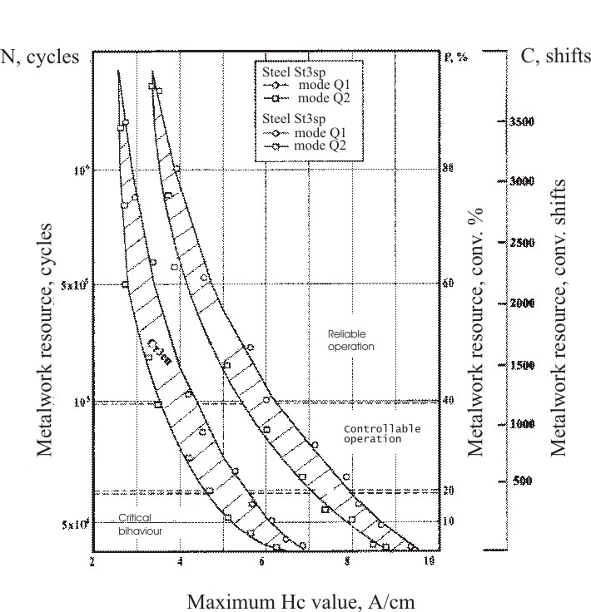

Figure 2. The nomogram for the magnetic test of residual life of
metalworks under ISO 4301.

The approach appeared to be also effective for:
- heat and hydro-electric engineering objects;
- real-time testing the mechanical properties of reactor shells;
- steelcasting and mill-rolling equipment;
- operating tests of bridges and hoisting cranes;
- equipment of engineering plants;
- testing the fatigue capacity of pipe metal;
- stop valve of gas and oil pipelines.

In all these cases the application of the coercimeteric technique allows to optimize the operational costs for the equipment maintenance and, as rule, reduce notably the production price. The operational costs became a controlled and an analyzed part of all enterprise expenses.
All the above reliably forms the basis for the metalwork operation ‘on state’, but not on its service life. Thereby, the value of coercive force in concentration zones should be included into the specifications of every new object or item. It is a necessary and simple starting condition to realize this up to date conception, because this kind of measurements only can follow the fatigue component of residual life in mass object testing.

